BI Concepts, Planning, and Implementation Project

Certificate in Business Intelligence and Database Development

**BI Concepts, Planning, and Implementation Project**

In this project, you **create, plan, and implement a BI solution** using a simple OLTP source database. The solution must include a SQL Server **Data warehouse** database, several SQL **ETL scripts**, an SSAS **Cube** database, an SSAS **Tabular** model database, a **MongoDB** Document database, and sample **reports**.

**This activity will take you about 15 to 20 hours over three weeks**, so plan accordingly!

# Project Scope

This BI solution is for a **small private school, with** **less than ten employees, interested in student enrollments**. You will create a prototype of the solution for evaluation. For the prototype, you need **only a few rows of sample data in each table**.

The project will be performed and **turned in as three milestone assignments**:

Milestone 1 (Assignment 8)

* Create a Visual Studio solution
* Review the OLTP source database (Azure Cloud)
* Create a **data warehouse**
* Create an **ETL** process script

Milestone 2 (Assignment 9)

* Create an SSAS **Cube** database
* Create a Tabular ETL Script
* Create an SSAS **Tabular** Model database

Milestone 3 (Assignment 10)

* Create a DocumentDB ETL script
* Create a MongoDB **Document** database
* Create sample **reports**
* Write a "Lessons Learned" document

**Important:** You are required to **submit your assignment** once for each milestone. You will get a **grade for the** **third submittal only**, while the **other two will be reviewed during class sessions** to help keep you on the right track!

# Milestone 01 (ASSIGNMENT 08)

In this Milestone, you start your BI solutions by designing, creating, and filling a data warehouse as you learned to do in modules 2, 3, and 4.

## The Visual Studio Solution

**Create an empty** Visual Studio **Solution** called **StudentEnrollmentProjects**, then **add** the following **two virtual and physical folders called Documents and SQLScripts** to organize your project.

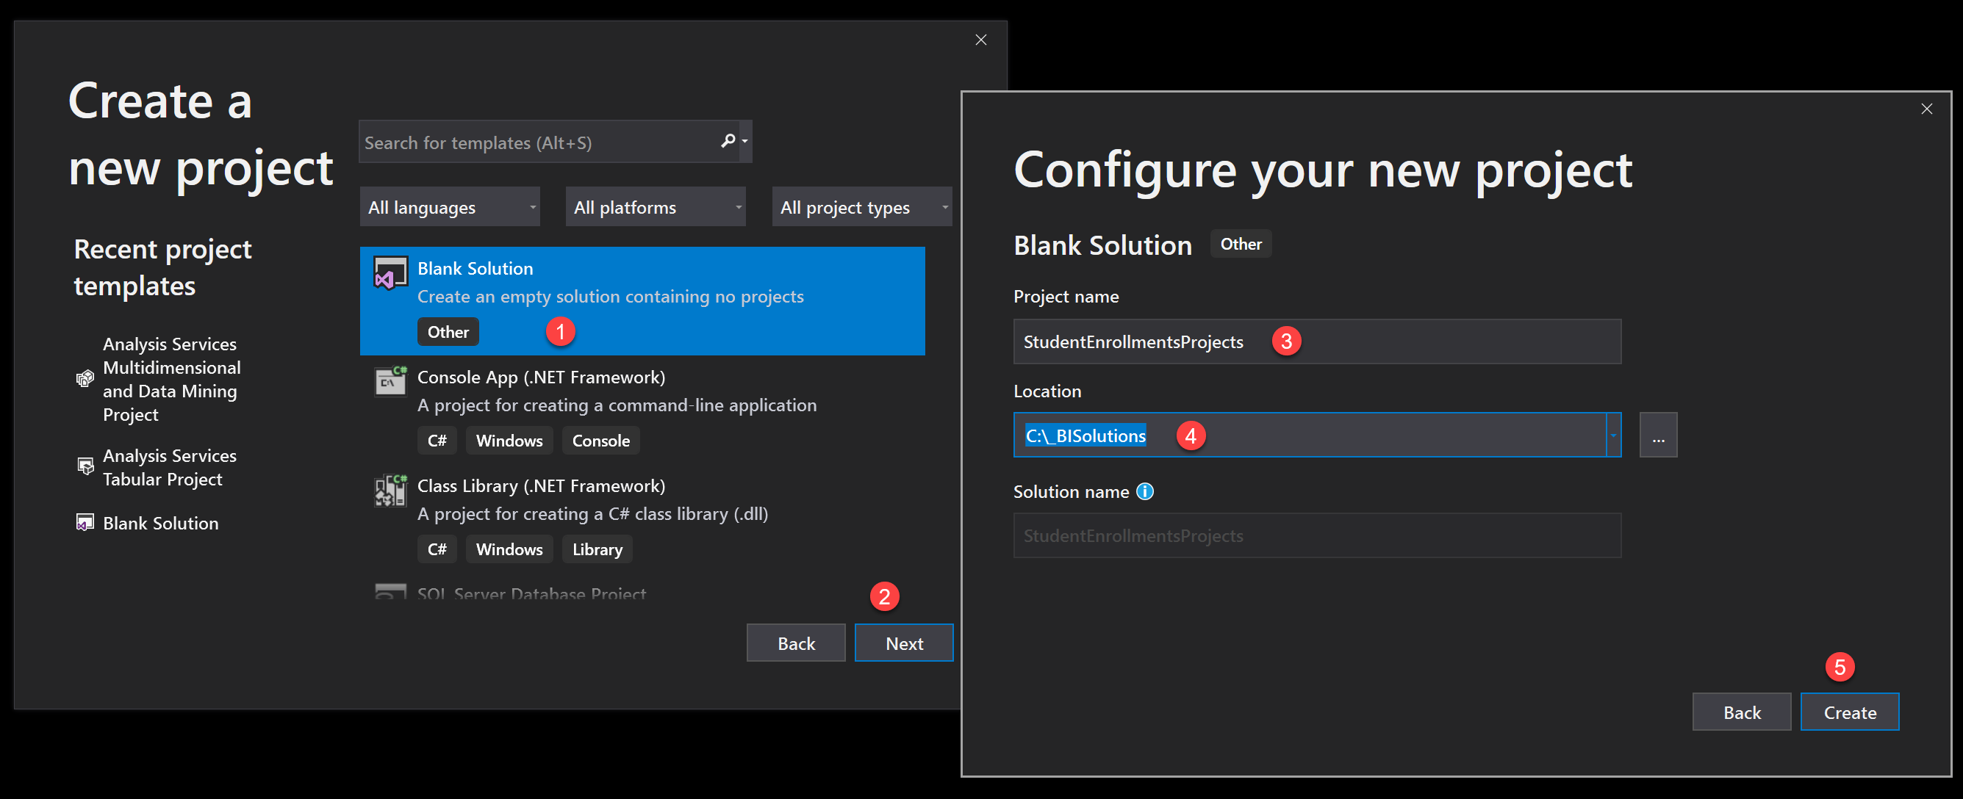

Figure 1: Starting the solution

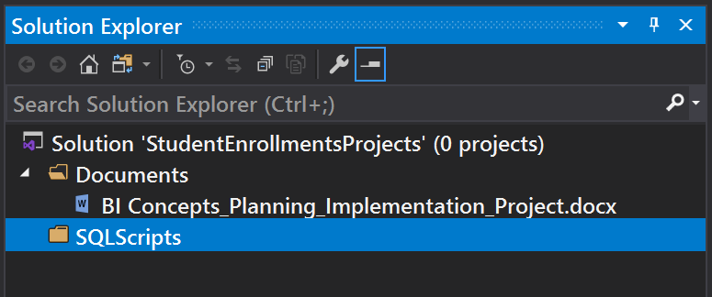

Figure 2: Creating the solution folders

## The OLTP Source Database

You need to **connect** and **review** an OLTP **source database** hosted **on the Azure cloud** by your instructor. Connect and review the tables using SSMS. **Note the tables, columns, constraints, and datatypes** of the **StudentEnrollments** database.

**Server:** continuumsql.westus2.cloudapp.azure.com

**Login:** BICert

**Password:** BICert

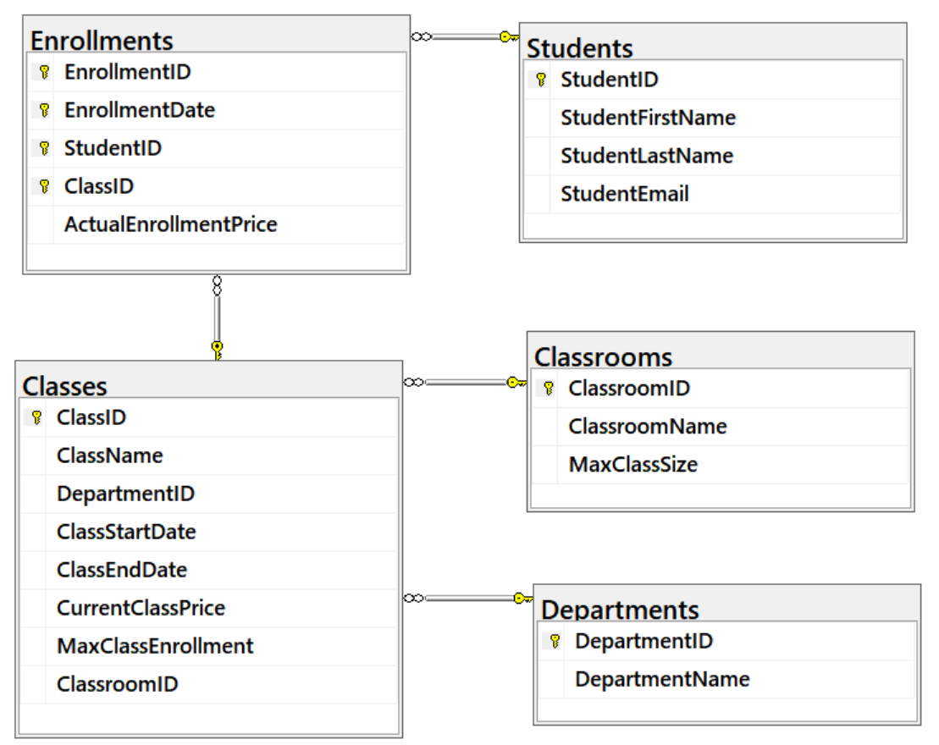

Figure 3: The source database

**Note:** You create all other databases on your personal "development" computer!

## The Data Warehouse Database

You must **design and create a data warehouse database on your local computer**, based on the StudentEnrollments database. Use the same techniques you learned in class to complete the "2-Create the DWStudentEnrollments database.sql" file.

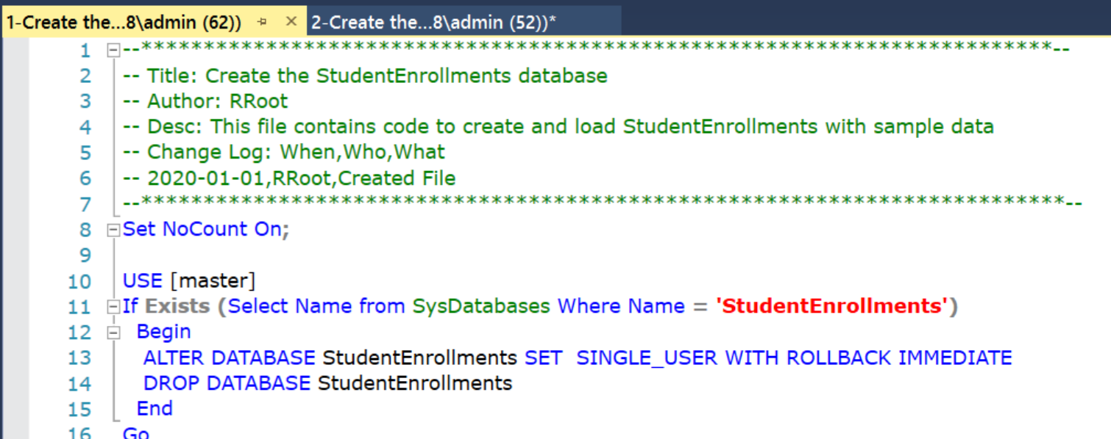

Figure 4: Creating the data warehouse database script

**Tips:** To make things easier:

* Do not connect the ClassStartDate and ClassEndDate to the date dimension table
* Choose a Star Schema Design

## The ETL Process Script

Create an **ETL process script** to **fill the local DWStudentEnrollments** database with data **from the Azure StudentEnrollments** database. Use the same techniques you learned in class to complete the "3-Perform the ETL process.sql.sql" file.

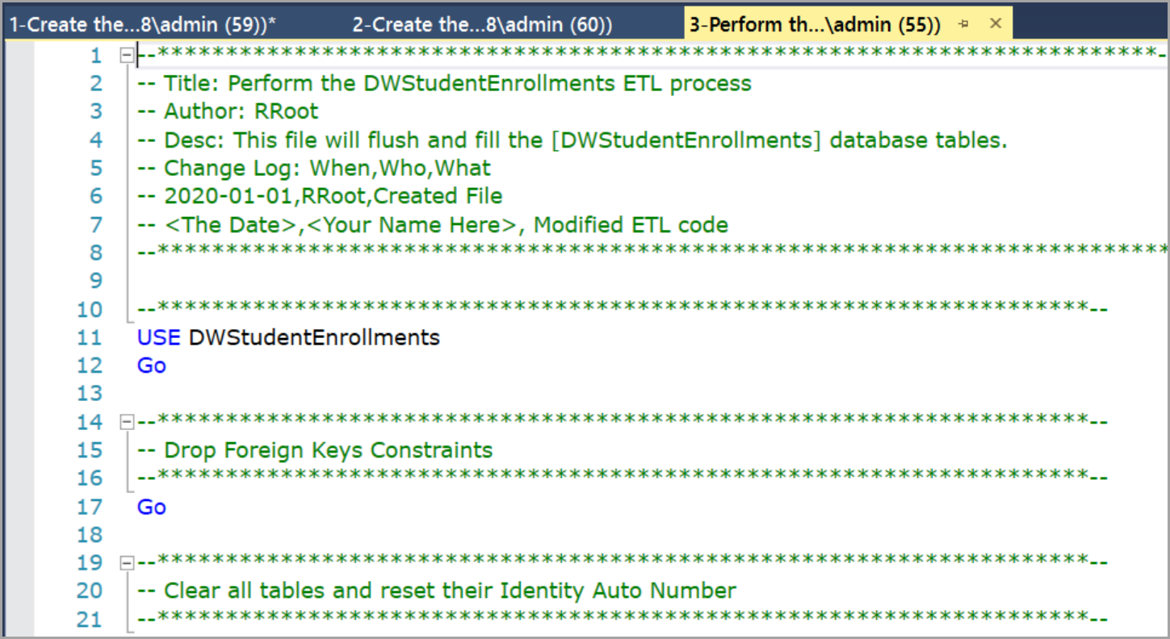

Figure 5: Creating the data warehouse ETL process script

## Submit your work to the Canvas

Once you finish the Milestone 01 tasks:

1. Place your scripts into both the **physical SQL Scripts folder and the VS virtual folders (Figure 6)**.
2. Use the **"Save All" button** in Visual Studio!
3. **Copy your current Solution folder** (the one with the .sln file inside it) **into a new folder called** "**StudentEnrollmentsFirstNameLastName**,"
4. **Compress the new folder** into a single zip file,
5. **Submit the zip file** on the Canvas website, under the Final Project Assignment.

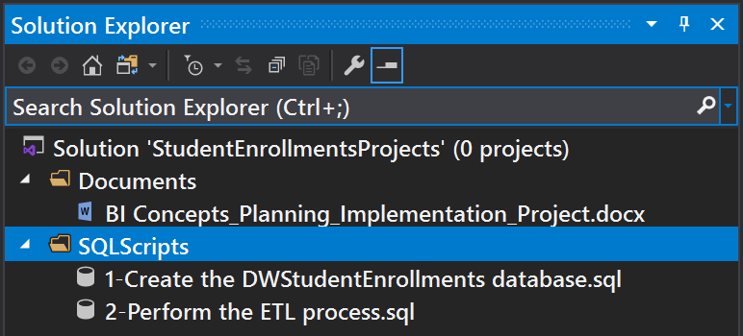

Figure 6: Adding the data warehouse and ETL process script to Visual Studio



Figure 7: Creating the copy of the solution folder for milestone 01 submittal

**Important:** You are required to **submit your assignment three times**, once for each milestone. **Submitting multiple times** to the same assignment **keeps all versions**, so your earlier work is not lost. You will get a **grade for the** **third submittal only**, but the **other two are reviewed during class sessions** to help keep you on the right track!

# Milestone 02 (ASSIGNMENT 09)

In Milestone 02, you create two SSAS databases and an SQL script that shapes the data for the tabular model. Use the techniques you learned in modules 5 and 6.

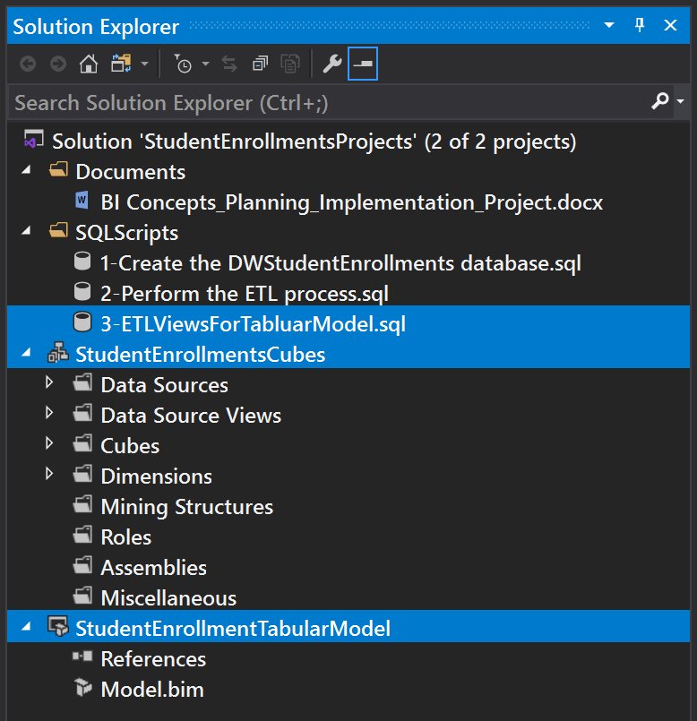

Figure 8: The projects and script required for milestone 02

***Important:*** *Start by* ***making any adjustments uncovered by*** *the Module09 Milestone01* ***Review*** *session.*

## The Cube SSAS Database

You need to **add an SSAS Cube project for your solution** called "**StudentEnrollmentCubes**." Create and configure dimensions and a cube **using** the data in the **DWStudentEnrollments** database. Process and Deploy to create the **StudentEnrollmentCubes database on SSAS**

**Tips**:

* Rename the columns and dimensions consistently
* Check the Key and Name properties for each dimensional attribute
* Check the relationships for each dimension hierarchy
* Include EnrollmentsID, Students, Classes, and Dates dimensions
* Include EnrollmentDollars and EnrollmentCounts measures
* Verify the measures and dimension data

## The Tabular ETL Script

Create a SQL script with ETL views to shape the data for your Tabular Model. Make one view for each DW table.

## The Tabular Model SSAS Database

You need to **add an SSAS tabular model project to your solution**, called "**StudentEnrollmentTabularModel**." Please use the integrated workspace option. Create and configure a Tabular Model using the data in the DWStudentEnrollments database. Process and Deploy to create the **StudentEnrollmentTabularModel database on SSAS**

**Tips**:

* Create an ETL View and convert the DateKey and EnrollmentDateKey columns to date:

*Convert(date, Cast([EnrollmentDateKey] as char(8)), 110)*

* Use ETL views to load data into your Tabular Model
* Set the Unique Property on each "table's" Primary Key column
* Create relationships between the columns
* Set the Date table using the converted Enrollment Date key.
* Check the relationships for each dimension hierarchy
* Include EnrollmentsID, Students, Classes, and Dates dimensions
* Include EnrollmentDollars and EnrollmentCounts measures
* Verify the measures and dimension data

## Submit your work to the Canvas

Once you finish the Milestone 02 tasks:

1. Place your script into both the **physical SQL Scripts folder and the VS virtual folders**.
2. Use the **"Save All" button** in Visual Studio (Figure 8)!
3. **Copy your current Solution folder** (the one with the .sln file inside it) **into a new folder called** "**StudentEnrollmentsFirstNameLastName.**"
4. **Compress the new folder** into a single zip file.
5. **Submit the zip file** on the Canvas website, under the Final Project Assignment.



Figure 9: Creating another copy of the solution folder for milestone 02 submittal

**Important:** You are required to **submit your assignment three times**, once for each milestone. **Submitting multiple times** to the same assignment **keeps all versions**, so your earlier work is not lost. You will get a **grade for the** **third submittal only**, but the **other two are reviewed during class sessions** to help keep you on the right track!

# Milestone 03 (ASSIGNMENT 10)

In Milestone 03, you create an **ETL script** for your document database, a **MongoDB document database**, and **several Excel reports**. You will also include a **document on what you have learned** this quarter. Use the technique you learned in modules 7, 8, and 9.

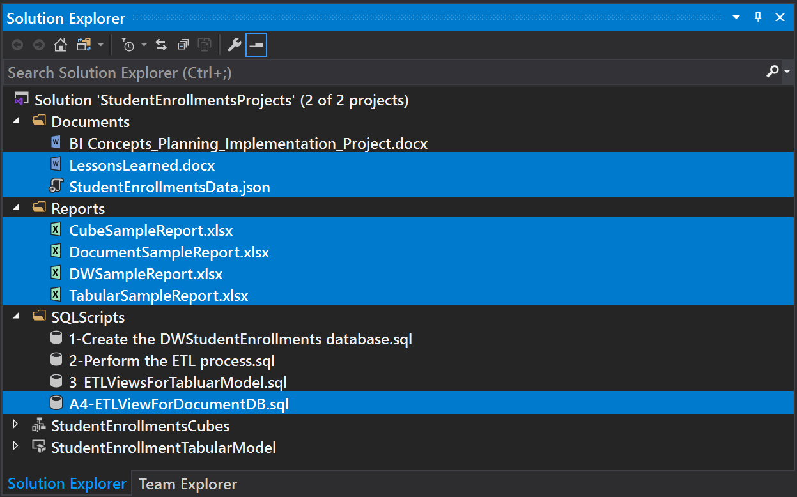

Figure 10: The projects and script required for milestone 03

***Important:*** *Start by making any* ***adjustments uncovered by*** *the Module09 Milestone02* ***Review*** *session.*

## The DocumentDB ETL Script

Create a script with an **ETL View** that shapes the data for the document database called "**ETLViewForDocumentDB**." The view should combine all of the data in the data warehouse tables.

## The Document Database

Create a **MongoDB database** called "**StudentEnrollmentDocumentDB.**" Add a collection called "**StudentEnrollments**" to the new database. Import the data from the ETL view and **export the data as a JSON** file called "**StudentEnrollmentsData.json**."

## The Sample Reports

Create **sample** **reports** using data from the **data warehouse, cube, tabular model, and document databases** (a total of 4 Excel reports.) Each report must include a header, a footer, and a body.

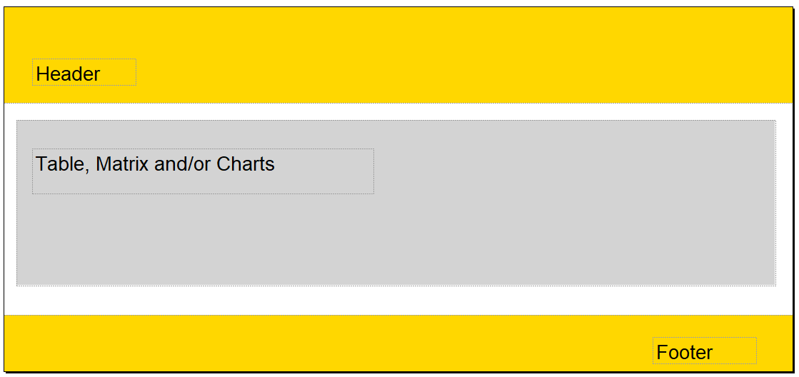

Figure 11: The typical format of each report

## The Lessons Learned Document

Write a paper that **outlines what you have learned in this class**. This document helps both you and myself to understand your progress in this course. You may be surprised to see how this process also solidifies what you have learned (or at least other students have told me it does!)

Tell about what you discovered about BI and database technology, the learning process. There is **no need to make this an exhaustive coverage** of what you did; a few paragraphs will do.

## Submit your work to the Canvas

After you complete your work, **Copy your current Solution folder** (the one with the .sln file) **into a folder called** "**StudentEnrollmentsFirstNameLastName**," **compress the folder** into a single zip file, then **submit the zip file** on the Canvas website, in the appropriate module Assignment.

1. Place your script and documents into both the **physical SQL Scripts folder and the VS virtual folders (Figure 10)**.
2. Use the **"Save All" button** in Visual Studio!
3. **Copy your current Solution folder** (the one with the .sln file inside it) **into a new folder called** "**StudentEnrollmentsFirstNameLastName.**"
4. **Compress the new folder** into a single zip file.
5. **Submit the zip file** on the Canvas website, under the Final Project Assignment.



**Important:** You are required to **submit your assignment three times**, once for each milestone. **Submitting multiple times** to the same assignment **keeps all versions**, so your earlier work is not lost. You will get a **grade for this** **third submittal.**